# How to Use GitHub and Manage Licensing

## 1. Setting Up GitHub

### Create a GitHub Account

* Go to GitHub and sign up for an account.
* Verify your email to activate your account.

### Install Git on Your Computer

* Download and install Git from git-scm.com.
* Open a terminal or command prompt and configure Git with your details:  
  
* Verify the configuration:  
  

**Example Output**

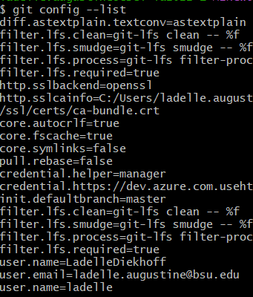

### Set Up SSH Authentication (Optional but Recommended)

* Check for an existing SSH key:  
  **ls ~/.ssh/id_rsa.pub**
* If there is no key, generate a new one:  
  **ssh-keygen -t rsa -b 4096 -C "your-email@example.com"**
* Copy the SSH key:  
  **cat ~/.ssh/id_rsa.pub**
* Go to GitHub → Settings → SSH and GPG Keys → New SSH Key → paste your key → Save.
* Test the connection:  
  **ssh -T git@github.com**

## 2. Creating a New Repository

* On GitHub, click **New Repository.**
* Enter a repository name and description.
* Choose public or private visibility.
* Initialize with a README if needed.
* Click **Create Repository**.

## 3. Working with Git Locally

### Clone an Existing Repository

* Copy the repository URL from GitHub.
* Run the following command in a terminal:  
  **git clone https://github.com/username/repository.git**
* Navigate into the cloned directory:  
  **cd repository**

### Create a New Local Repository

* Navigate to the desired directory:  
  **cd /path/to/your/project**
* Initialize Git:  
  **git init**
* Add a remote repository (if needed):  
  **git remote add origin https://github.com/username/repository.git**

## 4. Making and Committing Changes

* Add files or modify existing ones.
* Check the current status of your changes:  
  **git status**
* Add files to staging:  
  **git add**
* Commit the changes:  
  **git commit -m "Your commit message"**
* Push the changes to GitHub:  
  **git push origin main**

## 5. Branching and Merging

### Create a New Branch

* List existing branches:  
  **git branch**
* Create a new branch:  
  **git branch feature-branch**
* Switch to the new branch:  
  **git checkout feature-branch**
* Make changes, add, commit, and push:  
  **git add**  
  **git commit -m "feature update"**  
  **git push origin feature-branch**

### Merge Changes

* Switch to the main branch:  
  **git checkout main**
* Pull the latest changes:  
  **git pull origin main**
* Merge the feature branch:  
  **git merge feature-branch**
* Push updates to GitHub:  
  **git push origin main**

## 6. Managing Licensing [Paul Link]

### Choose a License

* Open **Choose a License** website to find the best license for your project.
* **Common licenses include**:
* MIT License (permissive, minimal restrictions)
* GPL License (requires derivative works to be open-source)
* Apache License (grants patent rights and liability protection)
* Creative Commons (ideal for non-software projects).

### Add a License to Your Repository

* In the repository root, create a LICENSE file:  
  **touch LICENSE**
* Open the file and paste the chosen license text.
* Commit and push the license file:  
  **git add LICENSE  
  git commit -m "Added LICENSE file"  
  git push origin main**

## 7. Best Practices

* Write clear commit messages.
* Use **.gitignore** to exclude unnecessary files.
* Create pull requests for collaborative work.
* Regularly pull changes to avoid conflicts.
* Use GitHub Issues for tracking bugs and features.